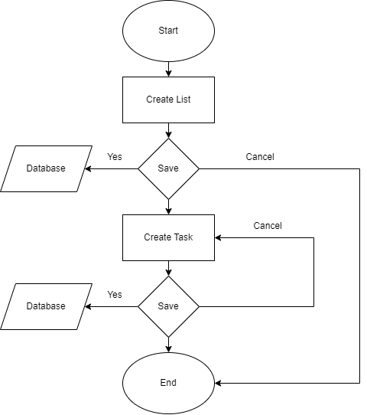In the diagram after creating a list you have an option to save the list if not the program will immediately end, when you save the list the list will be saved in the database, after creating a list you will create a task and also when saved will be directed to the database if not you will return to create a task.